Graphics Lies & Misleading Visuals

# Assignment

1. locate and identify a visual that displays misleading information
2. Identify mechanisms for misleading i.e. hiding relevant data, displaying too much data and obscuring reality, and distorting data through graphic forms
3. explain how it was used to mislead.

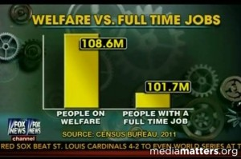

The infographic belongs to a Fox news channel, which is a part of a report on Fox News channel questioning how "poor" Americans really are. The aim of this information visualization was to exacerbate the issue that five times more people is receiving federal benefits than who are working at full time job. According to the data they have gathered it’s only about 1.06 times more people receive welfare.

**Source**: [This Bogus Graph is What Fox News Wants You to Believe About Poor People (mic.com)](https://www.mic.com/articles/70461/this-bogus-graph-is-what-fox-news-wants-you-to-believe-about-poor-people)

[(2232) Fox News: Are There Really Poor Americans? - YouTube](https://www.youtube.com/watch?v=xWpz9NQipp0)

**Intended Audience**: The public opinion for the purpose of reshaping their thoughts that there is a stark division between the two parties of poor and working-class people.

Because Fox News relies on the conservative belief that 47% of people take advantage of the resources provided by the government without paying their fair share. This is not the case. This is just more conservative drivel meant to incite class warfare at the expense of our nation's most vulnerable citizens.

# Misleading Components

* **Component:** Size of the bars
* **Mechanism**: ﻿ using graphic forms in inappropriate ways (distorting the data)
* **Explanation**: From the first glance you might expect that the number of people who enrolled in welfare programs are 5 times than those who had full time jobs. As you know numbers don’t lie but they have way small impact than visualization would suggest. This type of misinformation occurs when the graph’s producers ignore convention and manipulate the y-axis (***Truncated Y-Axis)***. The conventional way of organizing the y-axis is to start at 0 and then go up to the highest data point in your set. By not setting the origin of the y-axis at zero, small differences become hyperbolic and therefore play more on people’s prejudices rather than their rationality.